5.5 TEST MS
1. (a) Electron pair acceptor (1)
1
(b) Formula of gas CO2 (1)
Formula of precipitate V(OH)3 or [V(OH)3(H2O)3] (1) 2
[3]

2. (a) (i) Oxide or hydroxide dissolves (1)
in both acids and alkalis (1)
(ii) Equation 1 Cr(OH)3(H2O)3 or Cr(OH)3 + 3H+ → [Cr(H2O)6]3+ (1)
Equation 1 Cr(OH)3(H2O)3 + 3OH– → [Cr(OH)6]3–
or Cr(OH)3 or[Cr(OH)4(H2O)2]– (1) 4
(b) Plan add excess (1)
NaOH or NH3 (1)
filter (1)
removes Fe(OH)2 or Cr(III) in filtrate (1)
Formula of complex chromium (III) ion
[Cr(OH)6]3– or [Cr(NH3)6]3+ or [Cr(OH)4(H2O)2]– (1) 5
[9]

3. (a) 3d10 4s1 or reverse order (1)
3d9 (1)
(allow full configuration if correct; if wrong penalise once) 2
(b) (i) copper(II) hydroxide / tetraaquadihydroxycopper(II) hydroxide (1)
Cu(OH)2 / Cu(OH)2(H2O)4 (1) 2
(ii) idea of ligand exchange (Cl– for H2O) (equation acceptable) (1)
ligands not required, but any given must be correct
[Cu Cl4]2– (1)
tetrahedral / square planar (1) 3

[7]
4. (a) Co (1)
[CoCl4]2– (1)
[Co(H2O)6]2+ (1) 3
(b) Ag (1)
AgCl (1)
[Ag(NH3)2]+ (1) 3
(c) Cr (1)
[Cr(OH)3(H2O)3] or Cr(OH)3 (1)
[Cr(OH)6]3– or [Cr(OH)4(H2O)2]– (1) 3
[9]
5. (a) 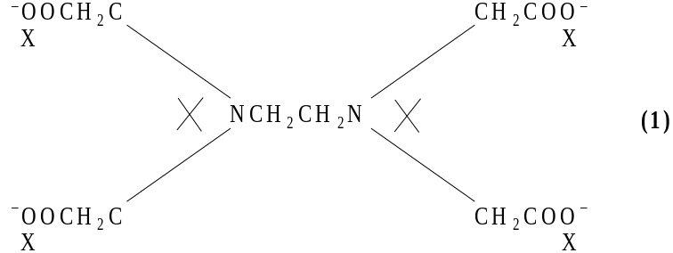 1
(b) (i) blue or blue-green (1)
[Cu(OH)2 (H2O)4] or Cu (OH)2 (1)
(ii) EDTA bonds to Cu2+ (1)
strongly (1)
or so no aqua ion present to hydrolyse 4
[5]
6. (a) Forms blue or pink or blue / green percipitate (1)
Not green
of Co(H2O)4(OH)2 etc (1)
(Precipitate) dissolves or forms a solution (in excess ammonia) (1)
Forms yellow or pale brown ‘straw’ (coloured solution) (1)
Containing [Co(NH3)6]2+ (1)
Darkens or goes brown on standing in air (1)
as [Co(NH3)6]3+ formed (1)
Due to oxidation (by O2 in air) or by reaction with oxygen (QoL) (1) 8
(b) Fe3+ has a large charge (1)
and smaller size than Fe2+ (1)
NB Fe3+ has a higher charge size ratio or higher surface density of charge or higher charge density scores (2)
NB Lose these two marks if candidates refer to either atoms or molecules
Greater polariation (of water) by Fe3+ or more hydrolysis occurs
or Fe3+ weakens the OH bond more
Allow converse statement
Fe2+ higher pH than Fe3+ or Fe3+ more acidic or solution of
Fe3+ contains more H+ (1) 4
NB allow marks for correct hydrolysis equation i.e.
[Fe(H2O)6]3+ [Fe(H2O)5(OH)]2+ + H+
if accompanied by a statement that this equilibrium lies further to the right for Fe3+ than for Fe2+ (1) and more H+ produced/pH lower (1)
(Allow converse statement)
Fe2+ with Na2CO3; green precipitate (1)
of FeCO3 (1)
Fe3+ with Na2CO3; (rust)/brown or red/brown percipitate (Not red) (1)
of [Fe(H2O)3(OH)3] etc
Allow Fe2O3.xH2O but not Fe2O3 (1)
and allow (carbon dioxide) gas evolved (1) 5
[17]

